
Department of BES-1
Data Structures Using Python
I -B.Tech-(II Sem), Academic Year: 2024-2025

Session-4 (Merge Sort)
Instructional Objective:
- To learn the concept of solving mergesort
- To find complexity of given Algorithm

Learning Outcomes:
- Define Merge Sort Algorithm
- Describe time complexity of merge sort
- Summarize Merge Sort Algorithm

1 Introduction:
Merge sort is a sorting technique based on divide and conquer technique. With worst-case time complexity being Ο(n log n), it is one of the most respected algorithms. Merge sort first divides the array into equal halves and then combines them in a sorted manner.
Algorithm:
Merge-Sort (a, first, last)
Step 1: if (first < last)
{
Step 2: mid = (first+last)/2 ;
Step 3: Merge-Sort(a, first, mid) ;
Step 4: Merge-Sort(a, mid+1, last) ;
Step 5: Merge(a, first, mid, last) ;
}
The above procedure sorts the elements in the sub array a[first...last].

To sort given any a[n] invoke the algorithm with parameters (a, 0, n -1).
We can assume each element in a given array as a sorted sub array. Take adjacent arrays and merge to obtain a sorted array of two elements. Next step, take adjacent sorted arrays, of size two, in pair and merge them to get a sorted array of four elements. Repeat the step until whole array is sorted.
Example: Input elements are : 28,27,43,2,7,82,10
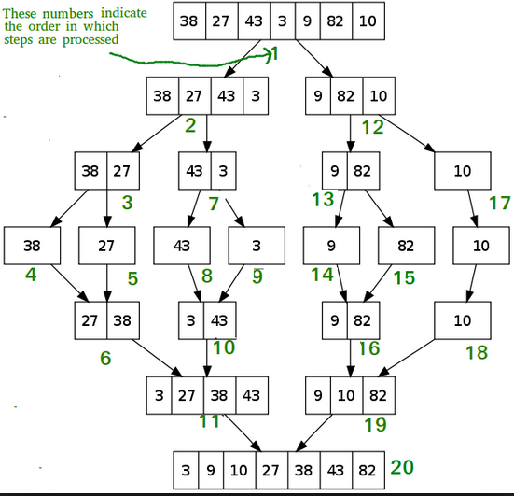
Sorted output: 3,9,10,27,38,43,82.

// C program for Merge Sort
#include <stdio.h>
#include <stdlib.h>

// Merges two subarrays of arr[].
// First subarray is arr[l..m]
// Second subarray is arr[m+1..r]
void merge(int arr[], int l,
int m, int r)
{
int i, j, k;
int n1 = m - l + 1;
int n2 = r - m;

// Create temp arrays
int L[n1], R[n2];

// Copy data to temp arrays
// L[] and R[]
for (i = 0; i < n1; i++)
L[i] = arr[l + i];
for (j = 0; j < n2; j++)
R[j] = arr[m + 1 + j];

// Merge the temp arrays back
// into arr[l..r]
// Initial index of first subarray
i = 0;

// Initial index of second subarray
j = 0;

// Initial index of merged subarray
k = l;
while (i < n1 && j < n2)
{
if (L[i] <= R[j])
{
arr[k] = L[i];
i++;
}
else
{
arr[k] = R[j];
j++;
}
k++;
}

// Copy the remaining elements
// of L[], if there are any
while (i < n1) {
arr[k] = L[i];
i++;
k++;
}

// Copy the remaining elements of
// R[], if there are any
while (j < n2)
{
arr[k] = R[j];
j++;
k++;
}
}

// l is for left index and r is
// right index of the sub-array
// of arr to be sorted
void mergeSort(int arr[],
int l, int r)
{
if (l < r)
{
// Same as (l+r)/2, but avoids
// overflow for large l and h
int m = l + (r - l) / 2;

// Sort first and second halves
mergeSort(arr, l, m);
mergeSort(arr, m + 1, r);

merge(arr, l, m, r);
}
}

// UTILITY FUNCTIONS
// Function to print an array
void printArray(int A[], int size)
{
int i;
for (i = 0; i < size; i++)
printf("%d ", A[i]);
printf("\n");
}

// Driver code
int main()
{
int arr[] = {12, 11, 13, 5, 6, 7};
int arr_size = sizeof(arr) / sizeof(arr[0]);

printf("Given array is \n");
printArray(arr, arr_size);

mergeSort(arr, 0, arr_size - 1);

printf("\nSorted array is \n");
printArray(arr, arr_size);
return 0;
}

2. Complexity Analysis of the Merge Sort Algorithm
Merge Sort is a divide-and-conquer algorithm that divides the array into two halves, recursively sorts both halves, and then merges them back together in sorted order. Here's a breakdown of its time and space complexity.

Algorithm Steps:
Divide the Array: Find the middle of the array and divide it into two sub-arrays.
Recursively Sort: Apply merge sort to each half (i.e., recursively break down the problem).
Merge the Sorted Halves: Once the sub-arrays are sorted, merge them back together in sorted order.

The function provided describes this process:
MergeSort(arr[], l, r)
If r > l:
1. Find the middle point: m = (l + r) // 2
2. Call mergeSort for the first half: mergeSort(arr, l, m)
3. Call mergeSort for the second half: mergeSort(arr, m+1, r)
4. Merge the two halves: merge(arr, l, m, r)

Time Complexity Analysis:
Let nnn be the number of elements in the array.
Divide Step:
At each level of recursion, the array is split into two halves, which takes constant time, O(1).

Recursive Sort Step:
In each recursive call, the array is divided into two sub-arrays, so the problem size is halved at each step.
At each level of recursion, you make two recursive calls for the two halves. This gives you a recurrence relation for the time complexity.
The time complexity T(n)T(n)T(n) follows the recurrence:
T(n)=2T(n/2)+O(n)T(n) = 2T(n/2) + O(n)T(n)=2T(n/2)+O(n)
2T(n/2)2T(n/2)2T(n/2) corresponds to the two recursive calls on the two halves of the array.
O(n) is the time to merge the two halves.
Merge Step:
Merging two sorted sub-arrays takes linear time, O(n), because every element from both sub-arrays needs to be checked and merged into the final sorted array.
To solve this recurrence relation, we use the Master Theorem:
T(n)=2T(n/2)+O(n)T(n) = 2T(n/2) + O(n)T(n)=2T(n/2)+O(n)
Here, the problem splits into two subproblems of size n/2, and the work done at each level of recursion is linear in n.
According to the Master Theorem, the solution to this recurrence is:
T(n)=O(nlog⁡n)T(n) = O(n \log n)T(n)=O(nlogn)
Therefore, the time complexity of Merge Sort is:
Best-case time complexity: O(nlog⁡n)
Average-case time complexity: O(nlog⁡n)
Worst-case time complexity: O(nlog⁡n)
Merge Sort always runs in O(nlog⁡n) time, regardless of the input data's initial order. This makes it a very reliable algorithm in terms of performance.
Space Complexity Analysis:
Auxiliary Space:
Merge Sort requires extra space to hold the sub-arrays during the merge step.
The recursive calls also add to the stack depth.
In total, the space complexity of Merge Sort is dominated by the space needed for the sub-arrays and recursive calls.
Merge Space:
During the merging process, we need additional space to store the merged arrays. This requires O(n) extra space.
Thus, the space complexity of Merge Sort is:
Space complexity: O(n)
Summary of Complexity:
Time Complexity:
Best Case: O(nlog⁡n)
Average Case: O(nlog⁡n)
Worst Case: O(nlog⁡n)
Space Complexity:
O(n)
Advantages of Merge Sort:
Stable Sort: Merge Sort preserves the relative order of equal elements.
Predictable Performance: It always runs in O(nlog⁡n) making it reliable even for large datasets.
Good for Linked Lists: Merge Sort works well on linked lists because it does not require random access to the elements.
Disadvantages:
Space Consumption: Merge Sort requires extra space for the merged sub-arrays, which makes it less memory-efficient compared to in-place algorithms like Quick Sort.

3. Summary:

In this session, it was discussed merge sort Algorithm and finding complexity algorithm

Self-assessment questions:
1.What is the average case time complexity of merge sort?
- O(n log n)
- O(n²)
- O(n² log n)
- O(n log n²)
2.Which of the following is not a variant of merge sort?
- in-place merge sort
- bottom up merge sort
- top down merge sort
- linear merge sort

Terminal questions

CLASSROOM DELIVARY PROBLEMS

- Explain Merge sort and its basics with an example.
- Here is an array often integers: 53 89 170 26 4 Draw this array after the TWO recursive calls of merge sort are completed, and before the final merge step has occurred.

PRACTICE PROBLEMS

Analyze the complexity of merge sort algorithm.
MergeSort(arr[], l, r)
If r > l
{
1. Find the middle point to divide the array into two halves: middle m = (l+r)/2
2. Call mergeSort for first half:
Call mergeSort(arr, l, m)
3. Call mergeSort for second half:
Call mergeSort(arr, m+1, r)
4. Merge the two halves sorted in step 2&3:
Call merge(arr, l, m, r)

